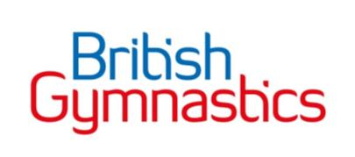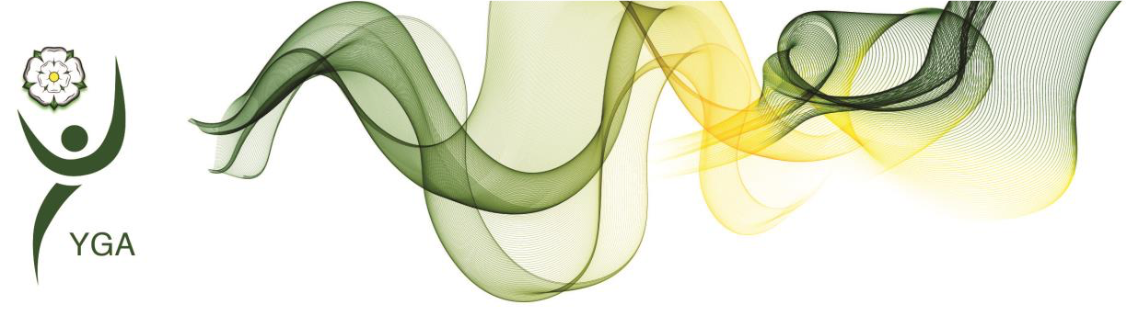

Yorkshire Regional General Gymnastics Competitions

4 Piece Competition - **Opal & Opal +**

Girls

Skills and Tariff sheet

|  |  |  |  |
| --- | --- | --- | --- |
| Key Information | | * Equipment dimensions can be found in the handbook * Non permitted elements are not allowed, and no Difficulty Value will be given if they are performed. * IMPORTANT – At all levels, coaches and gymnasts should concentrate their efforts towards the accuracy of technical execution. | |
| Floor Information | | * 8 elements are required * Ideally should include 4 Compositional requirements (CR) * Only permitted elements allowed * All holding elements are to be held for two ‘Mississippi’ (or similar choice of wording * Music length is required between 45’s-1min 15secs. * Longer music maybe used (max 1min 30secs) without a penalty but is not to be encouraged. Music longer than 1min 30secs will incur a penalty | Bonus |
| * Split leap showing min. 150 degrees split 0.2 * 2 Acro elements   joined 0.2   * Good use of directions, levels, and corners 0.3 * Bonus can be added to DV |
| Beam Information | | 6 elements are required (including mount & dismount)   * Must include 4 Compositional requirements (CR) * All holding elements are to be held for two ‘Mississippi’ (or similar choice of wording | * Exercise without a fall 0.50   [provided all CRs are fulfilled]   * 2 leaps or jumps joined 0.2 |
| * Beam Height - 125cm |
| * Matting to sit under the beam – optional 30cm |
| Bar Information | | * 4 elements are required * Must contain 4 Compositional requirements (CR) | * Cast to horizontal or above 0.3 * Exercise with no stops 0.2 * Stationery landing 0.2 |
| Vault Information | | * Vault height as per handbook, warm up vault to suit the group * Two attempts permitted on vault, best score to count | * Horizontal layout on the Squat / straddle vault1.0 |
| **Difficulty Value**  (DV Score) | Floor | * Each element is valued at 0.1 * Max DV score = 0.8 * Additional Elements performed don’t count towards DV score but may incur Execution Deductions * Bonus are added to the DV score | |
| Beam | * Each element is valued at 0.1 * Max DV score = 0.6 * Additional Elements performed don’t count towards DV score but may incur Execution Deductions * Bonus are added to the DV score | |
| Bar | * Each element is valued at 0.1 * Max DV score = 0.4 * Additional Elements performed don’t count towards DV score but may incur Execution Deductions * Bonus are added to the DV score | |
| Vault | * This is listed next to the vault skill on the criteria sheet * Bonus are added to the DV score | |
| **Compositional Score**  (C Score) | Floor | * For each Composition requirement (CR) selected, a value of 0.5 is added to the C Score. * Max C score = 2.0 * Choose 4 Compositional requirements (CR) for the list on the skills list. | |
| Beam | * For each Composition requirement (CR) selected, a value of 0.5 is added to the C Score. * Max C score = 2.0 * Choose 4 Compositional requirements (CR) for the list on the skills list. | |
| Bar | * For each Composition requirement (CR) selected, a value of 0.5 is added to the C Score. * Max C score = 2.0 | |
| Vault | This is not required in this part of the competition. | |
| Execution Score  (E score) | | * Scored out of 10.0 * See deduction table included within this document for guidance of the type of Execution Deductions judges will make | |
| SCORING INFORMATION | | * Difficulty Value (DV score) + Compositional Score (C score) + Execution Score (E score) = Starting score * Starting score – Judges Execution Deductions = Final Score | |



**OPAL (& OPAL +) 4 PC**

**Competition Criteria Updated May 2024)**

## **AGE GROUPS (in year of competition) 7&8, 9&10, 11&12, 13’s & over**

|  |  |  |  |  |
| --- | --- | --- | --- | --- |
| **Vault** | Handspring flat back 2.5  Through Vault 2.0  Straddle Vault 2.0  1.0 Bonus layout | Vault Height As per GG code | 2 x Vaults performed  Best score to count | |
|  | Uncoded Elements 0.10 each | (CR’s) Composition Requirements  4 @ 0.50 each | Bonus | Artistry & Specific Apparatus Deductions |
| **Bars** | Upward circle from 1 or 2 feet, (one board or 2 boards permitted) Jump from Springboard to front support on bar  Forward hip circle or backward hip circle, Float swing, squat on, ¾ giant from LB to HB or HB to HB, Counter swing,cast towards horizontal  Squat on and jump off forwards, from front support lower slowly forward to chin support and lower in control to long hang and release bar, straddle or pike undershoot, free undershoot from front support | 1.Upward circle from 1 or 2 feet  2.Forward hip circle or backward hip circle  3..Cast (can be attached to beginning of back hip or end of front circle or on its own  4.Dismount - . | 0.3 cast to horizontal or above  0.2 exercise with no stops  0.2 stationery landing | No deduction for empty swings |
| **Beam** | **Mounts**  Front support mount, squat on, Straddle on  Tuck jump, Straight jump, split jump  Scissor kick, Cat leap  ½ spin on 1 foot, releve turn  Forward roll, Backward roll, Cartwheel  Handstand (not held for 2 secs)  V-sit, Straddle lever hold, pike lever hold, Arabesque, Y balance  **Dismounts**  Round off dismount, Handspring dismount  Run into two feet jump dismount (optional jump – no rotation permitted)  Cartwheel into straight b/w jump dismount  Cartwheel to handstand and dismount | 1.Mount  2. ½ spin  3. Jump or leap  4.Acro element backwards  5. Acro element forwards  6. Acro element sideways  7. Balance for 2 secs.  8.Dismount | Exercise without a fall 0.50  [provided all CRs are fulfilled]  2 leaps or jumps joined 0.2 | Split jump allowed |
| **Floor** | Cat leap, Scissor kick, Stag leap, split leap, split jump, scissone, Tuck jump, Star Jump, Straight jump, ½ turn jump, full turn jump, W jump or hop, fouetté hop, full spin  Backward walkover, Forward walkover, Tic toc, Tinsica  Forward roll with optional exit,  Backward roll with optional exit, Side roll (from one straight leg via straddle), Handstand, Handstand forward roll, Backwards roll through handstand, Cartwheel (optional entry and hand support)Handspring to 1 or 2, Flyspring, roundoff, back flip, aerial, free walkover    Splits, Arabesque-balance, Y-Balance | 1.Dance passage of 2 leaps  2. Acro element forwards,  3.Acro element backwards  4. Spin 360 degrees or full jump turn  5. Acro element sideways  6.. Mixed series | Split leap showing min. 150 degrees split 0.2  2 acro elements joined 0.2  Good use of directions, levels and corners 0.3 |  |